**Question #1:**

.model small

.stack 100h

.data

greaterMsg db "First number is greater than second number.$"

lessMsg db "First number is less than second number.$"

equalMsg db "First number is equal to second number.$"

.code

main proc

mov ax, @data

mov ds, ax

mov ah, 01h

int 21h

mov bl, al

mov ah, 01h

int 21h

cmp bl, al

je Equal

jg Greater

jl Less

Greater:

mov dx, offset greaterMsg

mov ah, 09h

int 21h

jmp Terminate

Less:

mov dx, offset lessMsg

mov ah, 09h

int 21h

jmp Terminate

Equal:

mov dx, offset equalMsg

mov ah, 09h

int 21h

Terminate:

mov ah, 4Ch

int 21h

main endp

end main

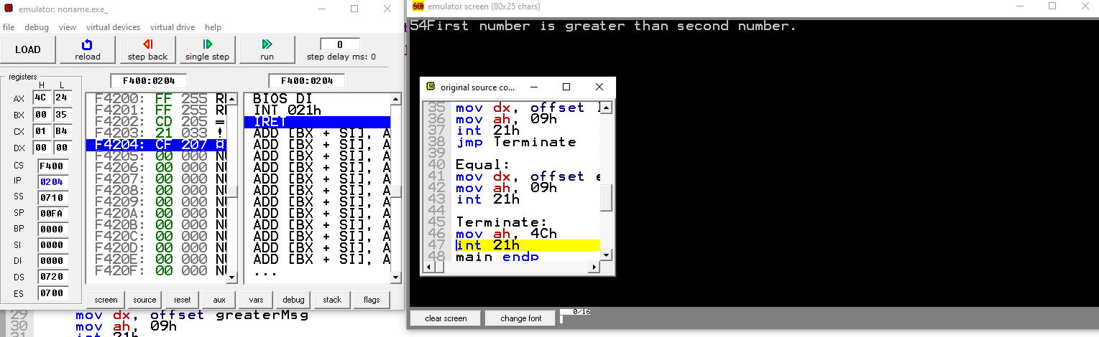

**Question 2:**

.model small

.stack 100h

.data

msg1 db "Enter first number (0-9): $"

msg2 db "Enter second number (0-9): $"

msgOp db "Enter operation (+ for addition, - for subtraction): $"

resultMsg db "Result: $"

addMsg db "Addition selected.$"

subMsg db "Subtraction selected.$"

invalidMsg db "Invalid operation.$"

result db 0

.code

main proc

mov ax, @data

mov ds, ax

mov dx, offset msg1

mov ah, 09h

int 21h

mov ah, 01h

int 21h

sub al, '0'

mov bl, al

mov dx, offset msg2

mov ah, 09h

int 21h

mov ah, 01h

int 21h

sub al, '0'

mov cl, al

mov dx, offset msgOp

mov ah, 09h

int 21h

mov ah, 01h

int 21h

mov dl, al

cmp dl, '+'

je L1

cmp dl, '-'

je L2

jmp Invalid

L1:

add bl, cl

mov result, bl

mov dx, offset addMsg

mov ah, 09h

int 21h

jmp DisplayResult

L2:

sub bl, cl

mov result, bl

mov dx, offset subMsg

mov ah, 09h

int 21h

jmp DisplayResult

Invalid:

mov dx, offset invalidMsg

mov ah, 09h

int 21h

jmp Terminate

DisplayResult:

mov dx, offset resultMsg

mov ah, 09h

int 21h

add result, '0'

mov dl, result

mov ah, 02h

int 21h

Terminate:

mov ah, 4Ch

int 21h

main endp

end main

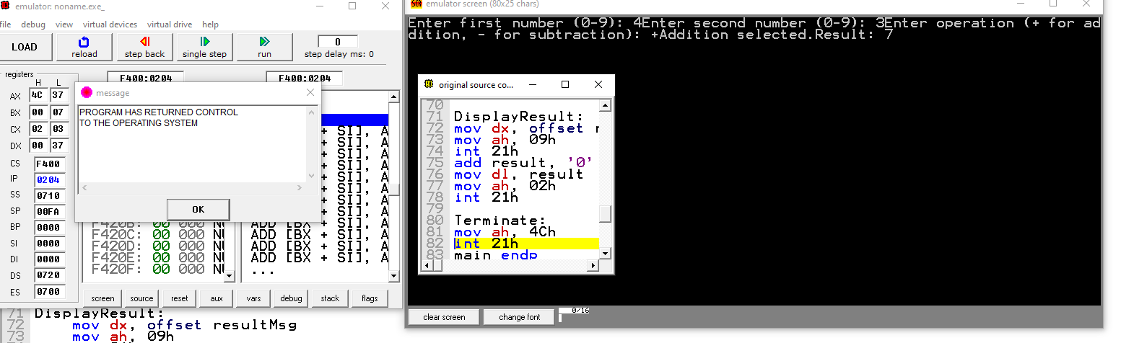

**Question #3:**

.model small

.stack 100h

.data

msg db "Enter a number (0-9): $"

evenMsg db "The number is even.$"

oddMsg db "The number is odd.$"

.code

main proc

mov ax, @data

mov ds, ax

mov dx, offset msg

mov ah, 09h

int 21h

mov ah, 01h

int 21h

sub al, '0'

and al, 1

jz Even

jmp Odd

Even:

mov dx, offset evenMsg

mov ah, 09h

int 21h

jmp Terminate

Odd:

mov dx, offset oddMsg

mov ah, 09h

int 21h

jmp Terminate

Terminate:

mov ah, 4Ch

int 21h

main endp

end main

